**Group 6**

1. Write a query that will delete a membership and all corresponding records.

Delete from Transaction where Transaction.MEMBERSHIP_ID = 100010;

Delete from Membership where Membership.MEMBERSHIP_ID = 100010;

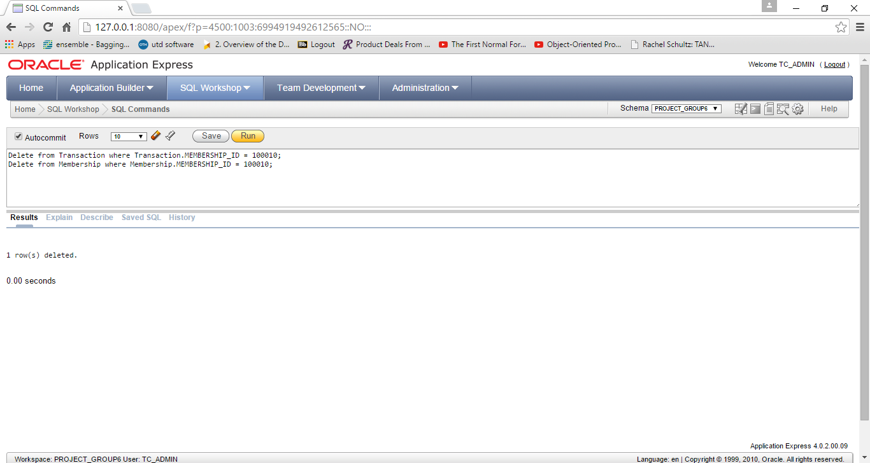

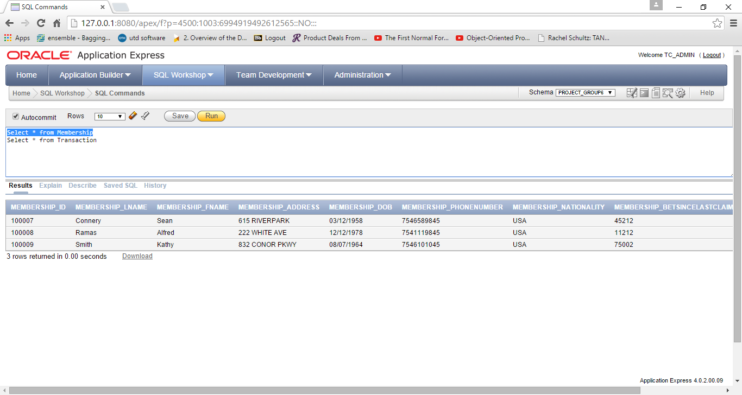

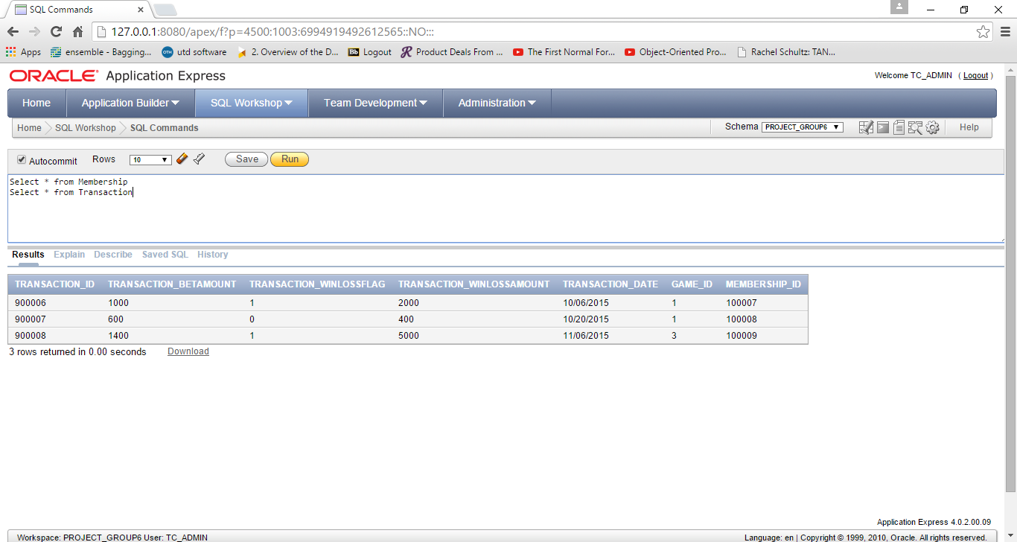

1. Display all cards that are assigned a membership.

Select * from card where Card_Id IN (Select distinct Card_Id from Membership)

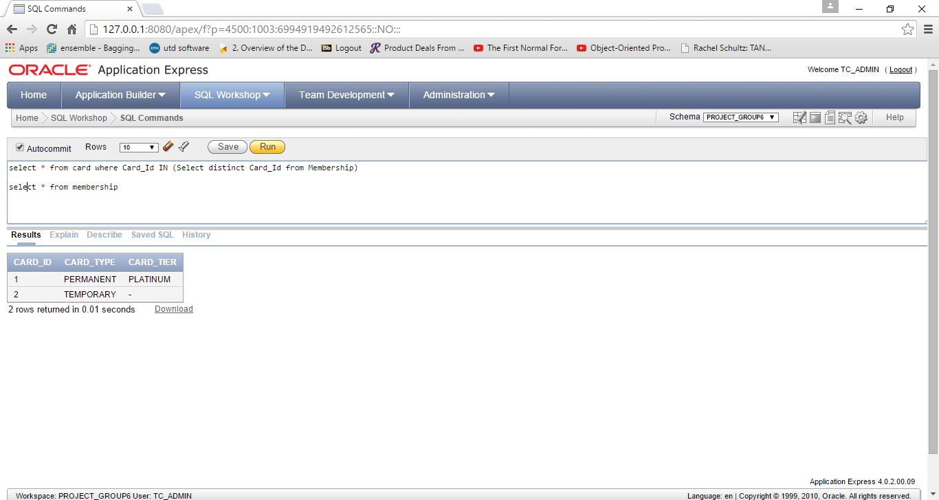

1. Display all members who have a cumulative total win amount > 500. Display the name and amount.

Select m.Membership_LName, m.Membership_FName,SUM(t.Transaction_WinLossAmount) as "Total_Win_Amount"from Membership m inner join Transaction t on m.Membership_Id = t.Membership_Id where t.Transaction_WinLossFlag = 1 group by m.Membership_LName, m.Membership_FName having SUM(t.Transaction_WinLossAmount) > 500

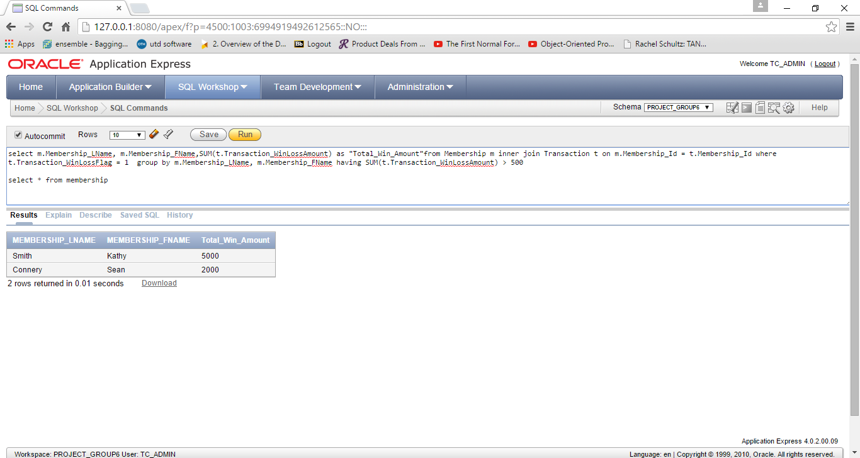

1. Display all transactions that occurred in October.
2. Which game has the most transactions? Display the games and the number of transactions for all games. Display the game name, type and count of transactions. Which game has the highest win amount?

Select Game_Type,Game_Name, Count(t.Game_ID) as "Count Of Transactions" from games g inner join Transaction t on t.Game_Id = g.Game_Id group by Game_Type,Game_Name

